Day 2 Assignment - Vamsi Viswanadham

Let’s say you have a pet adoption store, you have to track all the animals you have, what animals are adopted, on which date they are adopted, and where they have been adopted. So, to look over this data, you have to use SQL to store and process your store's data.

* Firstly you have to **create a database** to store all this table information.

So we created a Database named ‘**pet_adoption**’ and used it by using the below commands.

**CREATE DATABASE pet_adoption; #to create the database.**

**USE pet_adoption; #to use the database**

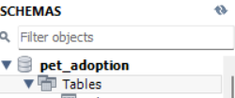

* Then create a table named ‘**animals**’ to store all the features of the animals you have by using the ‘create’ command as follows and insert the info regarding the animals you have as shown below.

**CREATE TABLE animals (id varchar(50) NOT NULL, name varchar(50), breed varchar(50), color varchar(50), gender varchar(50), status INTEGER);**

**INSERT INTO animals (id, name, breed, color, gender, status) VALUES ('89354034-20d9-4c3d-8195-3294bfd9dbc5', 'Bellyflop', 'Beagle', 'Brown', 'Male', 0);**

**INSERT INTO animals (id, name, breed, color, gender, status) VALUES ('89354034-20d9-4c3d-8195-3294bfd9dbc5', 'Bellyflop', 'Beagle', 'Brown', 'Male', 0);**

**INSERT INTO animals (id, name, breed, color, gender, status) VALUES ('ae91cf1c-f972-42f3-8160-6c04d935699c', 'Snowy', 'Husky', 'White', 'Female', 0);**

**INSERT INTO animals (id, name, breed, color, gender, status) VALUES ('37df3388-b0f4-4f0d-b6ef-0d840923a4d8', 'Princess', 'Pomeranian', 'Black', 'Female', 0);**

**INSERT INTO animals (id, name, breed, color, gender, status) VALUES ('94545432-d27a-4ac8-ab7c-38270d7535f3', 'Cricket', 'Chihuahua', 'Brown', 'Male', 0);**

**INSERT INTO animals (id, name, breed, color, gender, status) VALUES ('a1e7a7fc-b429-41ec-9924-8bb39dd397c8', 'Princess', 'Poodle', 'Purple', 'Female', 0);**

**INSERT INTO animals (id, name, breed, color, gender, status) VALUES ('5138ed53-2ab2-400b-973c-91186f8c673d', 'Spot', 'Dalmation', 'Black and White', 'Male', 0);**

Here We have created an animals table containing the following features as:

* Id
* name
* breed
* color
* gender
* status (whether adopted or not)
* Here is the result of the table ‘animals’ using **select * from animals;** command.

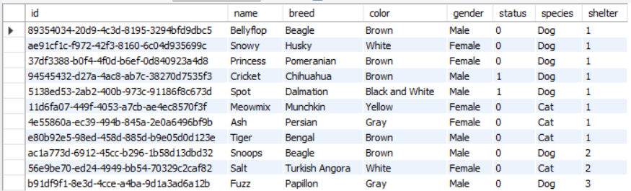

(Animals table after the last update.)

* You can see all the columns in the ‘animals’ using the **show** command as shown below.

**show columns from animals;**

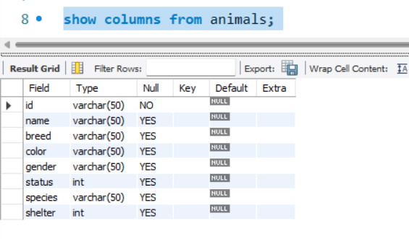

* Say you want all the female animals/pets you want, you can do this as:

**SELECT name FROM animals WHERE gender = 'Female';**

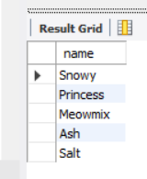

* If you have some errors in the table animals, you can update the data using ‘Update’ command as follows.

**UPDATE animals SET color = 'Brown' WHERE id = 'a1e7a7fc-b429-41ec-9924-8bb39dd397c8';**

**UPDATE animals SET color = 'Brown' WHERE name = 'Princess';**

**UPDATE animals SET color = 'Brown' WHERE color = 'Purple';**

**UPDATE animals SET status = 1 WHERE id = '94545432-d27a-4ac8-ab7c-38270d7535f3';**

Here you can use update command by selecting the table where you want to change the values, and what values you are changing.

* To see the changes that are made, use the **‘select * from animals**’ command.



* To track the status of the adoption of the pet, create another table named ‘adoption’ using the CREATE command as shown

**CREATE TABLE adoptions (animal_id varchar(50) NOT NULL, name varchar(50), contact varchar(50), date TIMESTAMP);**

Here adoptions table contains features such as

* animal_id
* name
* contact
* date
* Insert some data and see how the table gets modified using ‘INSERT’ command..

**INSERT INTO adoptions (animal_id, name, contact, date) VALUES ('94545432-d27a-4ac8-ab7c-38270d7535f3', 'Pinocchio', 'realboy@cockroachlabs.com', NOW());**

**UPDATE animals SET status = 1 WHERE id = 'a1e7a7fc-b429-41ec-9924-8bb39dd397c8';**

**INSERT INTO adoptions (animal_id, name, contact, date) VALUES ('a1e7a7fc-b429-41ec-9924-8bb39dd397c8', 'Patalie', 'poodlequeen@cockroachlabs.com', NOW());**

**UPDATE animals SET status = 1 WHERE id = '5138ed53-2ab2-400b-973c-91186f8c673d';**

**INSERT INTO adoptions (animal_id, name, contact, date) VALUES ('5138ed53-2ab2-400b-973c-91186f8c673d', 'Ella', 'ellacrew@cockroachlabs.com', NOW());**

**SELECT * FROM adoptions;**

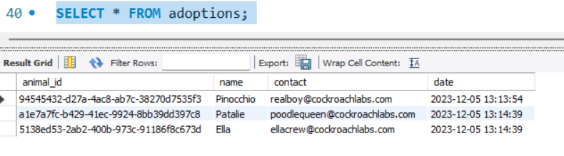

**Adoption table after the last update.**

* Check the adoption of each pet status by descending order of date using the following command that includes the ‘WHERE’ statement as shown below.

**SELECT * FROM adoptions ORDER BY date DESC;**

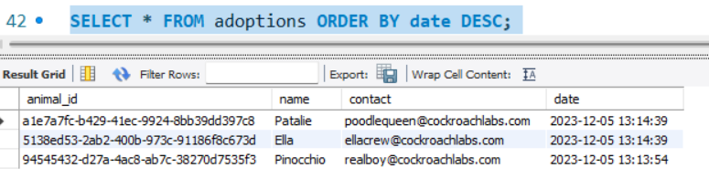

* Use the alter statement with the ADD COLUMN command to add a new column as shown below.

**ALTER TABLE animals ADD COLUMN species varchar(50);**

**ALTER TABLE animals ADD COLUMN shelter INTEGER;**

**select * from animals;**

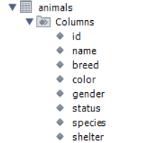

Here you can see a new column called ‘**species**’ is added to animals table.

* You can update the value of this new column using UPDATE command as shown below.

**UPDATE animals SET species = 'Dog';**

* In order to track the shelter of the pet that is adopted, you have to create a new table shelter using the CREATE command and insert values using the ‘INSERT’ command containing the features:
* id
* name
* location

**CREATE TABLE shelters (id INTEGER, name varchar(50), location varchar(50));**

**INSERT INTO shelters (id, name, location) VALUES (1, 'Animals 4 Homes', 'Red City');**

**INSERT INTO shelters (id, name, location) VALUES (2, 'Adopt A Buddy', 'Green Town');**

**INSERT INTO shelters (id, name, location) VALUES (3, 'Fluffy Animals', 'Blue Hills');**

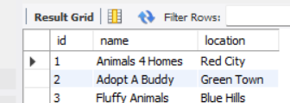

* You can delete a record from the animals' table if you have any need using the DELETE command as shown below.

**delete from animals where breed = 'Poodle';**

**Select * from animals;**

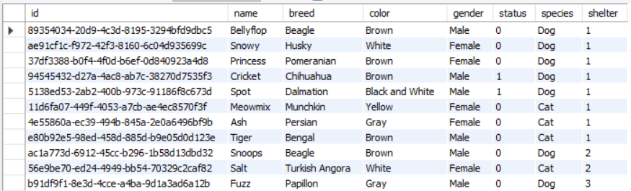

* You can also drop a table from the database using the DROP command as shown below.

**drop table shelters;**

* You can see whether it got deleted from the database using the SHOW command as shown below.

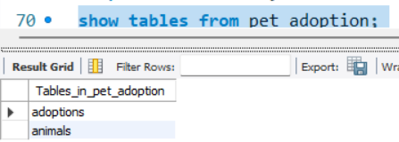

* **Here is a total list of queries used in this case study with the** [**file**](https://drive.google.com/file/d/13VIrGYyue6e9gQk7aQBO7jA4vaJOFLAj/view?usp=sharing)**.**

create database pet_adoption;

use pet_adoption;

show tables from pet_adoption;

CREATE TABLE animals (id varchar(50) NOT NULL, name varchar(50), breed varchar(50), color varchar(50), gender varchar(50), status INTEGER);

describe animals;

show columns from animals;

INSERT INTO animals (id, name, breed, color, gender, status) VALUES ('89354034-20d9-4c3d-8195-3294bfd9dbc5', 'Bellyflop', 'Beagle', 'Brown', 'Male', 0);

INSERT INTO animals (id, name, breed, color, gender, status) VALUES ('89354034-20d9-4c3d-8195-3294bfd9dbc5', 'Bellyflop', 'Beagle', 'Brown', 'Male', 0);

INSERT INTO animals (id, name, breed, color, gender, status) VALUES ('ae91cf1c-f972-42f3-8160-6c04d935699c', 'Snowy', 'Husky', 'White', 'Female', 0);

INSERT INTO animals (id, name, breed, color, gender, status) VALUES ('37df3388-b0f4-4f0d-b6ef-0d840923a4d8', 'Princess', 'Pomeranian', 'Black', 'Female', 0);

INSERT INTO animals (id, name, breed, color, gender, status) VALUES ('94545432-d27a-4ac8-ab7c-38270d7535f3', 'Cricket', 'Chihuahua', 'Brown', 'Male', 0);

INSERT INTO animals (id, name, breed, color, gender, status) VALUES ('a1e7a7fc-b429-41ec-9924-8bb39dd397c8', 'Princess', 'Poodle', 'Purple', 'Female', 0);

INSERT INTO animals (id, name, breed, color, gender, status) VALUES ('5138ed53-2ab2-400b-973c-91186f8c673d', 'Spot', 'Dalmation', 'Black and White', 'Male', 0);

SELECT * FROM animals;

SELECT name FROM animals WHERE gender = 'Female';

UPDATE animals SET color = 'Brown' WHERE id = 'a1e7a7fc-b429-41ec-9924-8bb39dd397c8';

SET SQL_SAFE_UPDATES=0; #to make updates enable at the start of using a database

UPDATE animals SET color = 'Brown' WHERE name = 'Princess';

UPDATE animals SET color = 'Brown' WHERE color = 'Purple';

UPDATE animals SET status = 1 WHERE id = '94545432-d27a-4ac8-ab7c-38270d7535f3';

CREATE TABLE adoptions (animal_id varchar(50) NOT NULL, name varchar(50), contact varchar(50), date TIMESTAMP);

describe adoptions;

INSERT INTO adoptions (animal_id, name, contact, date) VALUES ('94545432-d27a-4ac8-ab7c-38270d7535f3', 'Pinocchio', 'realboy@cockroachlabs.com', NOW());

UPDATE animals SET status = 1 WHERE id = 'a1e7a7fc-b429-41ec-9924-8bb39dd397c8';

INSERT INTO adoptions (animal_id, name, contact, date) VALUES ('a1e7a7fc-b429-41ec-9924-8bb39dd397c8', 'Patalie', 'poodlequeen@cockroachlabs.com', NOW());

UPDATE animals SET status = 1 WHERE id = '5138ed53-2ab2-400b-973c-91186f8c673d';

INSERT INTO adoptions (animal_id, name, contact, date) VALUES ('5138ed53-2ab2-400b-973c-91186f8c673d', 'Ella', 'ellacrew@cockroachlabs.com', NOW());

SELECT * FROM adoptions;

SELECT * FROM adoptions ORDER BY date DESC;

SELECT * FROM animals WHERE status = 1;

ALTER TABLE animals ADD COLUMN species varchar(50);

select * from animals;

UPDATE animals SET species = 'Dog';

INSERT INTO animals (id, name, species, breed, color, gender, status) VALUES ('11d6fa07-449f-4053-a7cb-ae4ec8570f3f', 'Meowmix', 'Cat', 'Munchkin', 'Yellow', 'Female', 0);

INSERT INTO animals (id, name, species, breed, color, gender, status) VALUES ('4e55860a-ec39-494b-845a-2e0a6496bf9b', 'Ash', 'Cat', 'Persian', 'Gray', 'Female', 0);

INSERT INTO animals (id, name, species, breed, color, gender, status) VALUES ('e80b92e5-98ed-458d-885d-b9e05d0d123e', 'Tiger', 'Cat', 'Bengal', 'Brown', 'Male', 0);

CREATE TABLE shelters (id INTEGER, name varchar(50), location varchar(50));

INSERT INTO shelters (id, name, location) VALUES (1, 'Animals 4 Homes', 'Red City');

ALTER TABLE animals ADD COLUMN shelter INTEGER;

UPDATE animals SET shelter = 1;

INSERT INTO shelters (id, name, location) VALUES (2, 'Adopt A Buddy', 'Green Town');

INSERT INTO shelters (id, name, location) VALUES (3, 'Fluffy Animals', 'Blue Hills');

INSERT INTO animals (id, name, shelter, species, breed, color, gender, status) VALUES ('ac1a773d-6912-45cc-b296-1b58d13dbd32', 'Snoops', 2, 'Dog', 'Beagle', 'Brown', 'Male', 0);

INSERT INTO animals (id, name, shelter, species, breed, color, gender, status) VALUES ('56e9be70-ed24-4949-bb54-70329c2caf82', 'Salt', 2, 'Cat', 'Turkish Angora', 'White', 'Female', 0);

INSERT INTO animals (id, name, shelter, species, breed, color, gender, status) VALUES ('b91df9f1-8e3d-4cce-a4ba-9d1a3ad6a12b', 'Fuzz', 3, 'Dog', 'Papillon', 'Gray', 'Male', 0);

delete from animals where breed = 'Poodle';

select * from shelters;

select * from animals;

Describe animals;

show tables from pet_adoption;

describe adoptions;

show tables from pet_adoption;

drop table shelters;

show tables from pet_adoption;

select * from shelter;